**CHAPTER IV**

**Result and Discussion**

The Grammar Encryption and Retrieval using NLP and Monte Carlo Algorithm is a newly developed software application that uses different techniques to encrypt and retrieve a text, the system will tokenize a sentence or paragraph by counting the number of words that will be replace by new words using Monte Carlo Algorithm and checking the grammar by using NLP Algorithm. The researchers will generate software Grammar Encryption and Retrieval using NLP and Monte Carlo Algorithm by the use of the best fitted Programming Language, Java Programming Language and used JDK 8.0.2 for compiling and running the source code.

**Encrypt original text into correct grammar**

The program first will get the input from the user. The user will enter text not more than 50 words and click edit then ok button. As shown in figure 1.0, the ENCRYPT button is disabled unless the tokenizing process has been execute by the program. The RETRIEVE button will be enabled if the encrypted file has a directory assigned in this program.

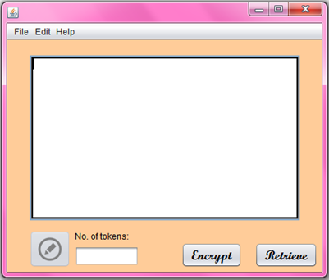

Figure 1.0 Enter a text to be encrypted

After clicking the ok button the message dialog will show up to enter the username and password of user. The user can also choose a text to be encrypted by clicking FILE button. As shown in Figure1.1, the file location come out and the user will choose a file to be encrypted but only text file is accepted in the system.

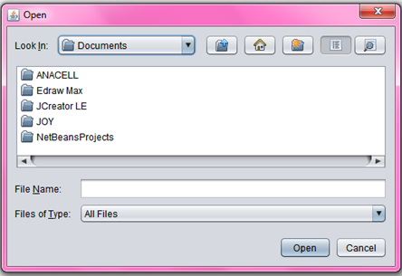

Figure 1.1 File Location of a file to be encrypted

Before encrypting process the program will generate the codes of tokenizing process that count the number of words to be encrypted.

Figure 1.3 shows the codes of Tokenizing.

codes

As shown in Figure 1.3 the process of tokenizing the text. The program will the number of words that are be replace during encrypting process.

The program will show up a message dialog if the user enters more than 50 words. The system will not execute the more than 50 words.

GUi that pop up invalid input of user

Figure1.3 shows the GUI of message dialog

The program will generate the codes that tokenize the text by counting the words that will be going to replace before applying Monte Carlo algorithm.

ENCRYPTION

Figure 1.3 Encrypt texts with correct grammar

After getting the format, Figure 1.3 shows the process of encrypting text by using Monte Carlo Algorithm